SOMALI REGIONAL STATE
BUREAU OF FINANCE

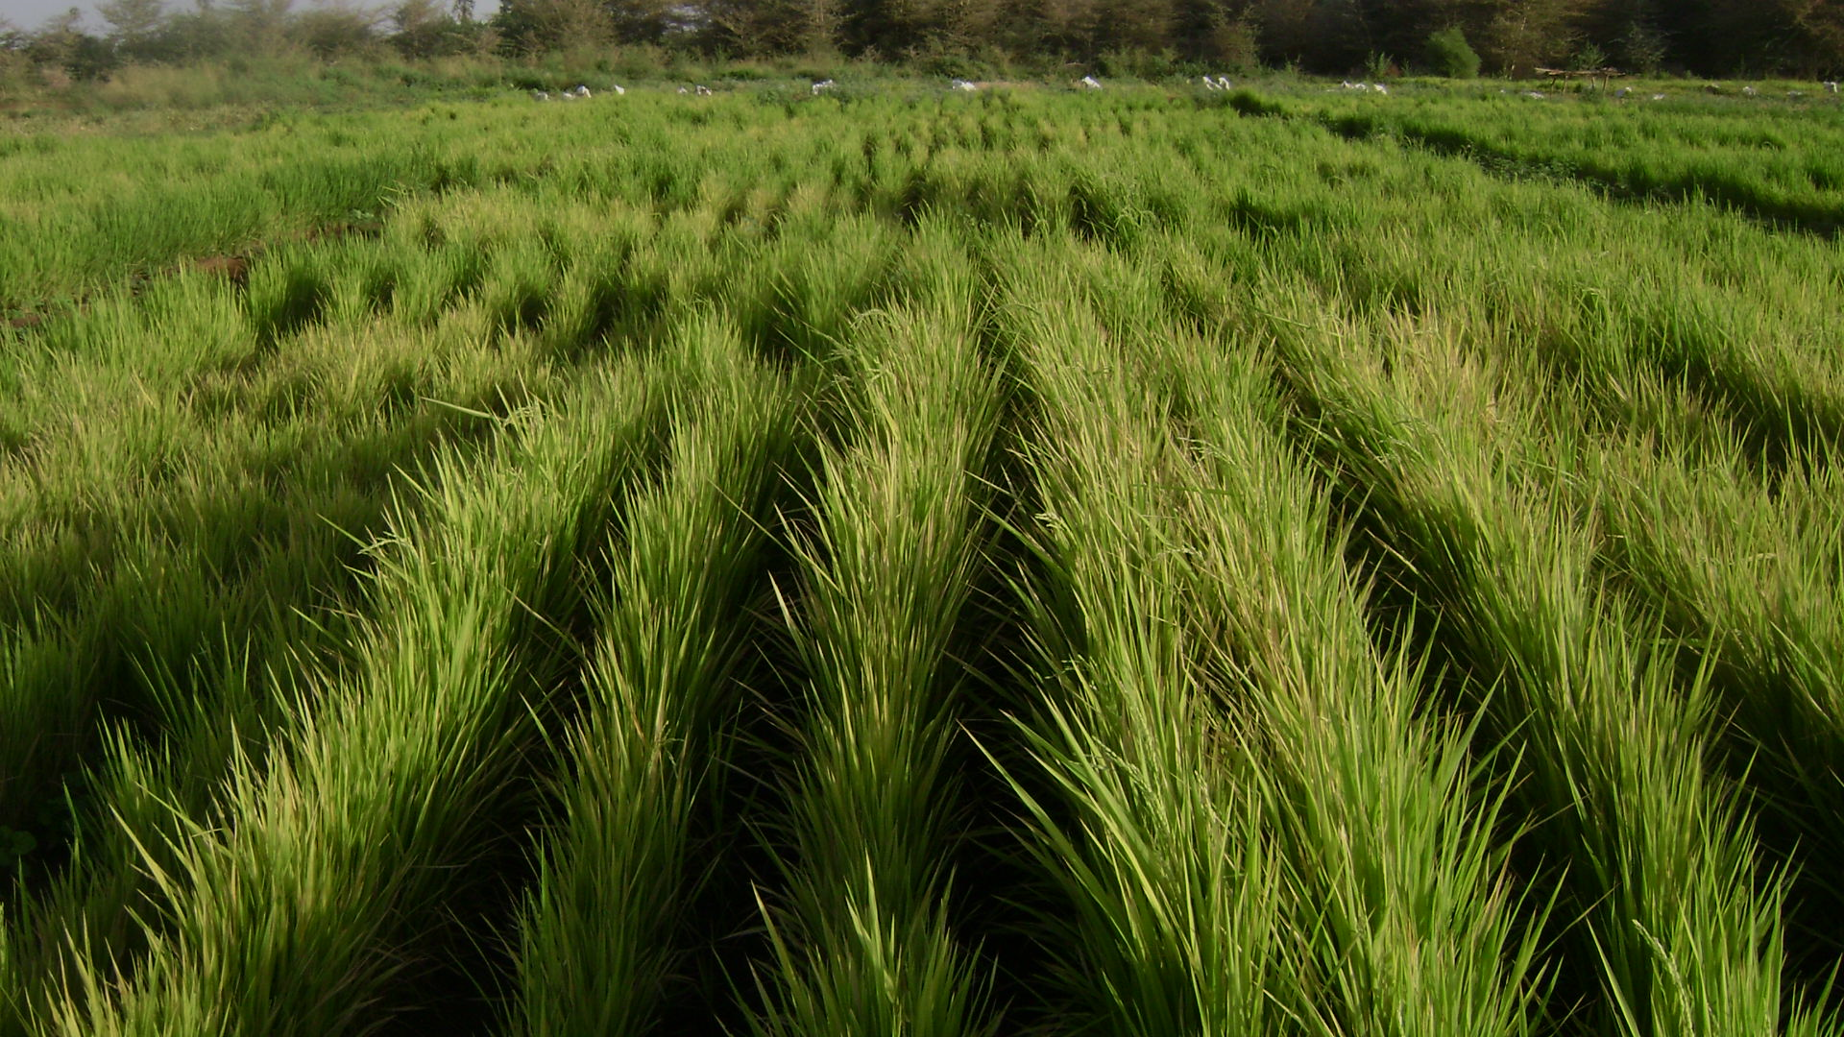
CITIZENS BUDGET FOR 2014 EFY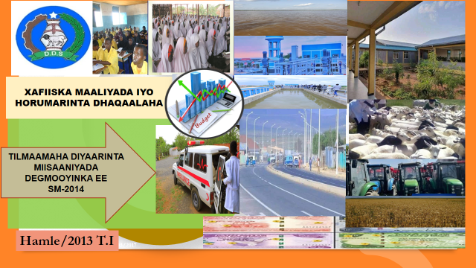
MASKEREM/2014 T.I
Table of Contents
Message from SRS BoF Head ii
Acknowledgements iii
Abbreviations iv
1. Introduction 1
1.1. A Brief Introduction of Citizens budget 1
1.2. Definition of Government budget 1
2. Macroeconomic update 2
2.1. Regional government economic situation 2
3. Expenditure performance (2010-2013 efy) 3
4. Strategic directions of Somali region for 2014 efy 4
5. Budget preparation process 4
5.1 Budget cycle 5
6. Where the government money will be spending? 11
6.1. Strategic allocation of resources in 2014 efy 13
7. Budget Terminology (Glossary) 15
8. Evaluation and planning for the future: 17

Message from SRS BoF Head
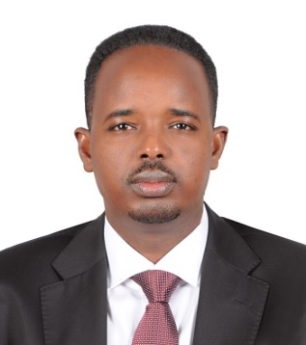
As the federal democratic republic of Ethiopia continues along the path of economic growth and development, the Somali regional government has made a great success over the past three years in terms of improving basic services, job opportunity creation, building infrastructure, and enhancing livelihoods. Hence, the current regional budget is in line with the priorities of our citizens and objectives of the regional ten-year development plan as well as global sustainable developments goals
Mr. Abdirahman Ahmed Hassen
SRS BOF Head
The resources used to finance such development endeavors mainly come from you, the taxpayers of the Somali region. For this reason, the Bureau of finance has prepared a Citizen’s budget book for 2014efy. Therefore, the government of the Somali region is willing that all community as a transparency and accountability manner understands the fundamentals of the regional budget. Furthermore, we seek to ensure that all segments of the Somali regions’ population are fully aware and knowledgeable about the budget expenditure and where the government money will be spending during the financial year beginning from the first Hamle 2013 EFY to the end of the sane month 2014 EFY. I hope that you will review the Citizen’s budget, which has been prepared in a non-technical way for your clear information. The aim is to allow the community to be more involved in Government’s plans and budget process. The bureau of finance welcomes the feedback on this first, ever Citizen’s Guide to the Regional government’s budget and we hope to improve over the years to come.

Acknowledgements

The Citizens Budget guide of EFY 2014 is the result of continues efforts done together by the technical working team of the Somali regional state bureau of finance. Thus, our gratitude is due to the two Deputy Bureau heads Mr. Abdirahman Salad and Mr. Muhedin Abdi for their support and guidance of producing this citizens’ budget guide.
In this juncture, we acknowledge to all members who actively participated the write up of this document. We thank all technical working team members of the bureau; particularly we appreciate Mr. Abdirahman Ahmed Matan, the director of budget, fiscal policy and M&E for his tireless contribution to the drafting, write-up and compilation of this document. We also thank Mr. Mohamoud Yusuf, the director of channel 1 programs and Mohamed Omer, the financial transparency and accountability focal person for their efforts during preparation, finalization and publication of this budget guide.

Abbreviations

SRS: Somali regional state
BBF: Balance Brought forward
M&E: Monitoring and Evaluation
EFY: Ethiopian Fiscal Year
MEFF: Macro-Economic and Fiscal Framework
ETB: Ethiopian birr
GDP: Gross domestic product
BOF: Bureau of Finance
G.C: Gregorian calendar
RSBs: Regional Sector Bureaus
MOFED: Ministry of finance
SDGs: Sustainable Development Goals

1. Introduction
A Citizens budget is a simpler, less technical version of the government's budget specifically designed to present key information to the public. Citizens Budget summarizes the information regarding Somali Region Government Budget for the financial year of 2014 Efy. It summarizes macroeconomic achievements, priorities of the budget, measures and guiding policies for budget, Sources and amount of revenue to be raised, and the expected expenditure outlays.
What is Budget: it is the knowledge of how to manage your income and expenditure. Budgeting is beneficial for individuals and families as well as for business people and governments.

A Brief Introduction of Citizens budget
Citizens’ Budget is prepared to present the annual regional government budget in a simple and clearly understood language to all citizens. Each year, Somali regional state prepares the budget and finally submits it to Parliament for discussion and approval.
The Somali region citizen’s budget guide summarizes the budget document and explains basic information on what services the government plans to deliver, how much they will cost, and finally enabling citizens to check if those services are delivered accordingly as indicated by financial transparency and accountability directive.

Definition of Government budget
It is a plan by the government that explains where revenues are coming from and how government will spend those revenues during a financial year. Indeed, budget is the key tool for the government to translate its policies into actions, and hence it helps to allocate resources to implement national policies and priorities for the medium term.
In case, where expected revenues are less than expenditures, the government considers the possibility of obtaining external debt under certain conditions if it is beneficial to the country or regions and it is possible to find the sources of its repayment.
The Somali regional parliament approves every year the expected revenue to be collected and its sources, expected spending by regional sector bureaus and subsidy to woredas and city administrations. In short, regional government budget is that regional spending should match regional domestic revenue mobilization.

Macroeconomic update
The macroeconomic and fiscal framework is a medium-term (three-five year) rolling expenditure and revenue plan that is prepared annually by regional government.
Most of the government development policies plans are medium–term horizon. The implementation of such policies and programs require sustainable commitment of government funding while they yield benefits over a period of years. The annual budget alone is hardly an appropriate tool to implement such policies and programs that have medium to long-term scope..
To address such issues the Somali regional government has introduced the medium term macroeconomic and fiscal framework (MEFF) to implement its programs. The framework covers the sources of financial resources (domestic revenues, subsidy from federal, loans and grants), as well as regional government recurrent and capital expenditures and subsidy to woredas and city administrations for five consecutive years.

Regional government economic situation

Four generic livelihood types exist in the region: pastoralist (comprising 60 percent of the rural population), agro-pastoralist farming (25 percent, livestock rearing, and rain-fed crop production), and sedentary and urban sector (15 percent). The average household consists of 6.3 persons. The main source of income for the rural population is livestock rearing, which constitutes 40 percent of the total income, while crop production constitutes 26 percent, trade 14 percent, and gift (in-kind) 7 percent.
During the past three years, Somali regional state has made great strides towards strengthening justice and security, protection of human rights, and freedom of speech, reducing poverty and unemployment and acceleration of economic growth.
The region has mainly targeted through implementation of pro-poor sectors and expansion of quality basic services, building infrastructure, system building and institutional capacity and human resource development and promoting democracy.
The region has been lacking behind the national level on almost all development indicators due to large land mass with scattered people, poor infrastructure, unique way of life and recurrent drought due to climate changes, that leads to financing challenges and shortage of budgetary resources at all levels over the past two to three decades.
The regional economy was expected to grow by 8 percent from EFY 2011-2013 (2018/2019-2020/21 G.C). However, the actual economic growth is expected to be lower than previously thought due to the Covid-19 epidemic and recurrent droughts.
As per the reports from federal government regarding inflation rate, the twelve months moving average recorded in EFY 2013 (March 2021) was 20.2 percent of the country's gross domestic product (GDP). The source of this growth is the price of food and non-food commodities.

Expenditure performance (2010-2013 efy)

In nominal terms, aggregate regional spending has increased from ETB 14.8 billion in 2010 efy to ETB 22.9 billion in 2013 efy, showing an annual average growth rate of 16 percent.
Description | Expenditure trends at all levels (2011-2013 efy) in ''million'' Birr
Ethiopian fiscal years | 2010 | 2011 | 2012 | 2013
Total Expenditure | 14,775 | 15,900 | 17,753 | 22,929
% increase |  | 8% | 12% | 29%

Strategic directions of Somali region for 2014 efy
- Emergency response to drought effects
- Completion of ongoing projects
- Improve education including vocational and technical programs.
- Improve health and nutrition aspect of the people
- Increase production and productivity of agriculture and livestock.
- Develop water resource infrastructure.
- Develop road infrastructure
- Urban development and jobs creation.
- Strengthen justice, security, and conflict resolutions
- Institutional and system building
- Improve women empowerment and child protection

Budget preparation process

A pre-budget discussion forum are held with community members at Woreda (District) level to identify basic services priority needs, which used as an input for Woreda annual planning.
Bureau of finance reviews past performances of macroeconomic and fiscal outlook of the region, then midterm expenditure and fiscal framework (MEFF) are prepared in order to estimate annual revenue and expenditure forecasts and submit to regional cabinet for approval, then BoF submits a budget call and circular letter to regional sector bureaus inviting them to submit next year's budget proposals. Regional sector bureaus submit their budget requests to BoF, then budget, fiscal policy and M&E directorate of BoF reviews all budget requests and conduct budget-hearing sessions, where each sector bureau brings their justifications to defend budget proposals. BoF submits recommended budget to the budget and finance committee of the parliament for further review and comments, then BoF submits a consolidated budget to the cabinet, which may amend it before approval. Finally, the regional council approves and appropriates the budget. After that, BoF submits approved budget notifications in detail by account codes and projects to regional sectors. Woredas and city administrations will be informed their approved budget subsidies based on block grant formula.
During the beginning of Hamle, each sector bureau prepares annual implementation action plan, procurement plan and cash flow forecasting and then submit to planning bureau, BoF, and procurement agency respectively.

  - Budget cycle

Financial Calendar
# | Activity | Responsible body | Timing
 | Budget preparation stage
1 | MEFF preparation | BoF | December 16-30
2 | Issue budget call to Sector Bureaus | BoF | January 31- February 15
3 | Submit Budget Requests to BoF | RSBs | March 21 – April 15
4 | Recommend RSBs’ budget requests | BoF | April 16-30
5 | Submit a draft budget to Budget and Finance committee of the council | BoF | May 01-15
6 | Endorsement of the budget | Cabinet | June 15
 | Budget Approval Stage
7 | Appropriation of the budget | Council | July 7
 | Budget Execution/Implementation
8 | Notify approved budget to RSBs | BoF | July 7 –July 15
9 | Prepare an annual implementation action plan and cash flow forecasting | BoF & RSBs | 8 July – 15 July
10 | Budget Adjustments | BoF & RSBs | Ongoing
11 | Budget oversight/Auditing | Auditor general | Ongoing

Where does the budget come from (Source of Budget)

In a bid to achieve the objective of enhancing the self-financing of developmental endeavors, great efforts will be put to boost up the domestic revenue-generating capacity. Domestic revenue mobilized this year will be 7.6 billion birr at all levels. The budget remains above all a forecast, its successful implementation depends on the mobilization of planned resources, particularly the domestic revenue of the region.
Source of budget for 2014 efy
Description | Total
Ethiopian fiscal year | 2014
Grant total revenue including subsidy and external assistance | 29,209,304,471
Total regional domestic revenue | 7,600,000,000
Tax revenue | 6,674,540,191
Non-tax revenue | 925,459,809
Subsidy from federal | 21,003,703,085
External assistance | 214,946,515
Balance brought forward (BBF) | 390,654,871

The expected total revenue, including grants and subsidy from the federal government in the coming fiscal year, are planned to be 29.2 billion birr excluding donor funds provided through the so-called Channels 1 and 2, and investment funds from NGOs and other development partners operating in the region, which provide implementation of a significant projects and programs every year.

In this regard, subsidies from the federal government including sustainable development goals (SDG), external assistance, domestic revenue mobilization gained from the regional economy, and balance brought forward (BBF) were identified to be sources of regional government budget for 2014 efy.

An illustration about sources of budget for 2014 efy

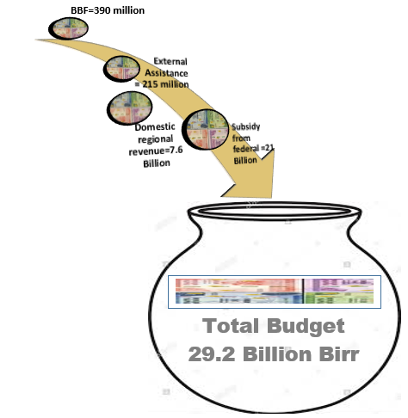
Subsidy from the federal government including SDG and external assistance takes the largest share, accounting for 73 percent of the planned total budget. The domestic revenue expected to generate from the regional economy mainly on tax and non-tax sources accounts for 26 percent, in addition to that balance brought forward takes 1 percent of the total resource.

Source of budget and comparison between 2013 and 2014 EFYs (on budget only)
S/n | Description | Total source of budget
 |  | EFY 2013 | EFY 2014 | Difference between 2013 & 2014 efy | % Increase
 | Total resource | 22,313,522,702 | 29,209,304,471 | 6,895,781,769 | 31%
1 | Federal subsidy from Central Treasury | 17,051,657,591 | 19,806,103,085 | 2,754,445,494 | 16%
2 | External Assistance | 161,510,000 | 214,946,515 | 53,436,515 | 33%
3 | Subsidy from federal (Sustainable Development Goals) | 598,800,000 | 1,197,600,000 | 598,800,000 | 100%
4 | Domestic revenue | 4,200,000,000 | 7,600,000,000 | 3,400,000,000 | 81%
5 | Balance brought forward (BBF) | 301,555,111 | 390,654,871 | 89,099,760 | 30%

As can be seen from the above table, the total planned budget of the region has increased 31% in 2014 efy as compared to the previous year of 2013 efy. External assistance has also increased 16%, while sustainable development goals, which is a specific grant fund, intended to finance projects and programs enabling the region to achieve global SDGs has increased 100% this year. Domestic revenue will increase 81%.

Where the government money will be spending?

In terms of budget allocation across the broad categories, the largest share of the regional money is to finance economic services (34 percent), followed by general development services (33 percent), social services (31 percent), and finally contingency budget (2%).
General budget categories for 2014 efy

Description | Recurrent | Capital | Total | Share (%)
Total Budget | 13,804,585,094 | 15,404,719,377 | 29,209,304,471
General development | 6,624,369,532 | 2,924,801,303 | 9,549,170,835 | 33%
Economic development | 1,316,045,386 | 8,566,365,601 | 9,882,410,987 | 34%
Social development | 5,164,170,176 | 3,913,552,473 | 9,077,722,649 | 31%
Others (Contingency) | 700,000,000 |  | 700,000,000 | 2%

Type of budget at all levels for 2014 efy
At all levels, 47 percent of the total budget will be spent on financing recurrent expenses primarily wages and salaries, which accounts for nearly on average 34 percent of the regional total budget, operating cost is 13 percent. On the other hand, the capital budget is 53%, which is much larger than the recurrent budget.
Type of budget | Total amount | Percentage (%)
Recurrent budget (Salary & operating) | 13,804,585,094.00 | 47%
Capital budget | 15,404,719,377.00 | 53%
Total Budget | 29,209,304,471.00

In the Somali region, the capital budget dominates at the bureau level due to the high cost of capital investments allocated under regional sector bureaus; such as construction of hospitals, colleges, deep and/or shallow wells and roads based on expenditure assignments between bureaus and woredas. Woredas and city administrations will spend nearly 60 percent of their total budget on salary payments particularly on teacher and health technician salaries due to operationalizing the stock of existed and expanding new facilities.

Recurrent and capital budget at bureau and district level in 2014 efy
Description | Salary | Operating | Capital | Total
Bureau level | 3,630,000,000 | 2,849,155,849 | 12,107,707,388 | 18,586,863,237
District and City administration level | 6,405,330,082 | 920,099,163 | 3,297,011,989 | 10,622,441,234
Total Budget | 10,035,330,082 | 3,769,255,012 | 15,404,719,377 | 29,209,304,471

Recurrent and capital budget at all levels in 2014 efy
Description | Total budget | Percentage (%)
Salary | 10,035,330.08 | 34%
Operating cost | 3,769,255.01 | 13%
Capital budget | 15,404,719.38 | 53%
Total Budget | 29,209,304.47 | 100%

Strategic allocation of resources in 2014 efy

The 2014 efy budget is allocated to the priority sectors in ten-year development plan on education, health, water, agriculture, urban development, job-creation and roads,

Budget allocation by sector for 2014 efy
S/n | Name of sectors | Allocated budget | Share (%)
 | Total Budget for 2014 efy | 29,209,304,471
1 | Agriculture sector | 3,093,002,738 | 11%
2 | Water resource development | 2,173,917,841 | 7%
3 | Urban development, Housing and job-creation | 2,633,641,393 | 9%
4 | Education sector | 4,877,050,217 | 17%
5 | Health sector | 3,100,181,440 | 11%
6 | Rural roads and transport | 1,026,611,621 | 4%
7 | Justice and Security sector | 4,307,767,376 | 15%
8 | General Governance | 3,862,339,334 | 13%
9 | Other sectors | 4,134,792,511 | 14%

Education and Health Care Equal 28 Percent of Somali Regional State Budget at all levels for efy 2014

Budget Terminology (Glossary)

Budget Call: A Circular by BOF that contains budget preparation forms, instructions and procedure for preparation and submission of detailed budget estimates.
Budget Formulation: the process of determining the resources necessary for organizations to carry out its programs, perform its mission, and to achieve strategic objectives and goals.
Budget oversight: monitors the execution of the budget, to provide checks and balances on the enacted budget.
Budget Request: an itemized summary of expenditure of an organization over a specified period, usually a financial year submitted to BOF.
Budget Subsidy (Budget grant): Budget support provided by Federal government or an amount of budget approved by regional council provided to woredas and city administrations by BoF.
Capital Expenditure: the expenditure of funds by government for an asset that is expected to provide utility for organizational service provision
Recurrent Expenditure: expenditure on goods and services that does not result in the creation or acquisition of fixed assets, and which consists mainly of expenditure on wages, salaries and supplements, purchases of goods and services
Citizens' Budget: a document that summarizes and explains basic public budget information presented to citizens in an accessible format using simple and clear language.
Domestic Sources: the process through which government raise and spend its own funds from different sources within the region to provide services for its people.
External Assistance: support from external sources for budgeting to fulfill expenditure obligation by the government for a given fiscal year.
Ethiopian Fiscal Year (EFY): a period used by the government for annual financial statements from July 08 to July 7 (From Hamle 01 to Sene 30 according to Ethiopian Fiscal Year).
Fiscal Policy: Government spending and taxation to influence the economy.
Financial Resource/Revenue: sources of finance from which government obtains the funds it needs to finance its investments, capital and recurrent activities.
Fiscal framework: the determination of financial resources available for expenditures during the fiscal year.
Medium Term Fiscal Framework: fiscal arrangements that allow government to extend the horizon for fiscal policy making beyond the annual budgetary calendar. Three-year spending plans of the government.
Inflation Rate: the percentage change in the price index for a given period compared to that recorded in a previous period. A price index means a weighted average of the prices of a selected basket of goods and services relative to their prices in some base-year.
Macro-economic: the structure, performance, behavior, and decision-making of the whole or aggregate economy.
Macro-Economic Fiscal Framework (MEFF): the framework provides the context under which fiscal targets are set, policy choices are determined, and realistic revenue and expenditure projections are prepared.
Pre-Budget Discussion: a discussion forum held with community members at Woreda (District) level to identify basic services priority needs, which used as an input for Woreda annual planning.
Rolling Expenditure: a continuous budget that is updated regularly when the earlier budget period expires or it is an extension of the current period budget.

Evaluation and planning for the future:

To evaluate the Somali region’s citizen budget, we must have the answers of the questions like:
Is the Citizens Budget meeting the objectives for which it was created — to enhance public understanding of the government’s budget and enable citizen participation in the formulation, implementation and assessment of the budget?
This is the central question, which the bureau of finance should ask itself throughout the process of developing and disseminating a Citizens Budget.
Because of the importance of a Citizens Budget and the challenges involved in producing it, evaluation of its effectiveness in informing people and promoting their involvement is essential. It is an evaluation of the process followed to develop and disseminate the Citizens Budget, as that process is also critical to initiating and sustaining a dialogue between the government and the public. As citizens’ Budget is new; therefore, evaluation of process and impact is much important.
As mentioned in Chapter one, Citizens’ Budget is published annually. Planning for next year’s Citizens Budget should build upon an analysis of and reflection on the current year’s efforts. In that way, those responsible for undertaking the evaluation will have collected the necessary data to undertake a proper evaluation at points along the way.
The sorts of questions for the different steps in the process of developing and disseminating a Citizens Budget that should arise in an evaluation would be:
Planning: Were the objectives in our strategic plan for this year’s Citizens Budget sufficiently clear?
Consultation: Were our initial assumptions about the likely users of the Citizens Budget correct?
Dissemination: Were there potential users for the Citizens Budget whom we did not reach this year?
Production of Citizen budget what was our experience in taking the recommendations from the consultation and trying to integrate them into our existing objectives, assumptions, and plans.
Were there elements of the recommendations that presented little problem? Why? What was particularly challenging, and why was it challenging?
Questions for Citizens budget Evaluations
- Does the newly produced citizen’s budget meet the objective of government’s budget?
How, clarify it ________________________________________________
______________________________________________________________

- Were our initial assumptions about the likely users of citizens’ budgets correct?
- Were there potential users for the Citizens Budget whom we did not reach this year?
- What was our experience in taking the recommendations from the consultation and trying to integrate them into our existing objectives, assumptions, and plans?
- Were the terms used in the citizens’ budget document clear enough for the end-users?

Feedback Questions for the users;
- What are your ideas, comments, and questions on this newly prepared citizens budget in 2014
___________________________________________________________________
___________________________________________________________________
___________________________________________________________________
- Are there more information that is not included in the citizens budget other than this if YES, list them down
_____________________________________________________________________
_____________________________________________________________________
- To what extent is this booklet useful? very useful □ moderate □ not useful □
In not useful, please define it_____________________________________________
______________________________________________________________________
- Was the booklet easy to read and understand? □ Very Easy □ Moderatess □ Uneasy If it was Not Easy, Please explain

For more information, please contact:
Somali Region, Bureau of Finance (BoF)
Jig-jiga/ Ethiopia
Tel: +257752406
Mobile: +251911071596
Fax: +257752916
www.srbofed.gov.et

