SOMALI REGIONAL STATE

BUREAU OF FINANCE AND ECONOMIC DEVELOPMENT

INVESTMENT PROJECT FUND (IPF)

EFY 2012 Annual Performance Report on:

Financial Transparency and Accountability (FTA)

By: Mohammed Omer
FTA Focal person

Hamle, 2012 E.C

Executive Summary

This Report Provides an overview of FTA Performance for the year 2012 EFY which includes the specific status of main FTA activities such as Budget literacy Training and other activities. It also discusses tools used to spread the FTA Message to citizens that includes information templates, banners and Media etc.
Furthermore, the report deals with workshop creation awareness on FTA, training, intended to improve skill gap of Council Members both regional and woredas. The report also shows FTA Committees established at woreda level to speed up the implementation scope of the program and innovations.
The methods used to ensure FTA Performance status include planned activates compared to execute and the targets achieved as well as objectives set.
All details are shown in the body of the report.
The FTA status Result achieved show that; Although implementation of FTA at Regional level is pretty good, in which some Regional sector Bureaus displayed their budget in the year 2012, however, they are expected to do more in the upcoming EFY, unlike woredas did, when it comes to Annual Budget Dissemination to citizens, since 99% of all woredas announced their budget on time during that period though, some woredas have been reluctant about conducting Citizens pre-budget discussion.

The performance of the Regional sector bureaus are not sounding.
The major area of weakness requires collective responsibility.
To sum up, the general performance of the SRS BoFED about FTA looks very good.

Recommendations:
- Increasing creations awareness on FTA should be expanded to regional sector bureaus.
- Creating sense of ownership on regional and woreda Officials.
- Empowering planning and budgeting staff both in regional and woreda as FTA Focal persons.
- Continues evaluation of the program is essential.

INTRODUCTION

1.1 Purpose

The purpose of this report is to present the major performance of financial Transparency and Accountability (FTA) during the year 2012 and Objectives Achieved. It will also recommend the Major ways forward for the Upcoming 2013 and better strategies to successfully achieve the objectives of the program.

1.2 Background.

In an effort to reduce poverty and enhance decentralized public service delivery to the poor, the Government of Ethiopia (GoE) and international development partners have embarked on a new mechanism known as Investment Project Fund (IPF) aimed to Promote Poverty reduction and sustainable development of member countries by providing financial and related operational support to specific project that promote broad-based economic growth, contribute to social and environmental sustainability, enhance the effectiveness of public and private sectors, or otherwise contribute to overall development of member states. Investment project financing is comprised of Bank loans and bank guarantees. IPF supports projects with defined development objectives, activities and results. Investment project financing May also supports an MPA program. The bank disburses the proceeds of Bank loans against specific eligible expenditures. Therefore, unlike PBS, IPF is approved to Finance Financial Transparency and Accountability. (FTA) as a result,
During the year (2012), The Somali Region has undertaken many works on FTA which intended to ensure citizens’ participation throughout the Public financial Management processes and aimed promoting sense of ownership and accountability within the community.

The Major activities Planned were:
- Carry out Budget literacy Training and provide 50 for each 40 Woreda.
- Carry out workshop creation on FTA for regional council.
- Carry out workshop creation on FTA for woreda council.
- Print, distribute and fill 4,500 FTA Templates to post service canters at Woredas.
- Print and disseminate FTA Audit and procurement templates.
- Print, fill and post 8 Big banners on Regional Budget disseminated for the year 2012.
- Make woredas to organize and conduct citizens’ Pre-budget discussion during 2011 in almost 75 woredas in both rural and urban areas.
- Establish 2 New FTA Clubs at each woredas.
- Make Drama on FTA and Broadcast through local media like SRTV.
- Follow up formerly established FTA Clubs at school and ensure how they function.
- Establish Local Community development Committee at eight woredas in Fafan and jarar zones.
Executed FTA activities during 2012 EFY
So, major tasks executed during this period were as follows:
- Based on the agreement reached with in Somali region local media, disclosure of regional Public budget was frequently transmitted through FM, Radio of -Somali Region Television (SRV) on weekly basis.
- At least, 8 large banners depicting 2012 EFY Regionally allocated Budget were posted at several popular areas in Jigjiga City.
- At Woreda level, the 2012 EFY budget Approval of districts and City Administrations were posted on poster, Banners and Billboards.
- 4,500 Information templates have been printed and disseminated and also distributed to all woreda to post local budget allocations which is approximately 75% service delivery areas.
- At both district and city administration level, Awareness creation on Participatory Public Planning and Budgeting (BLT) was provided to 2,000 (971Male and 1029 females). The Participants composed of religious leaders, Traditional elders, women, youth, students, school teachers, Woreda staff, and SAC Committee. Also, in order to accomplish this activity, Manuals of Planning and budgeting was distributed to participants.
- 1200, Stickers, posted on laptops, viewing Annual Approved Public budget and planning process have been made and disseminated.
- Workshops for Woreda and kebele Parlements on the Promotion of FTA has been organise and provided to more than 250 participants.

- Regarding FTA implémentation at Régional Bureaus, sectors disseminated their annuel Budget to Citizen by using large banners posted jus at front of their offices and some public areas.
- All woreda and City administrations Posted Approved budget for the year 2012 EFY by using all methods of budget dessimation such as Posters, banners, stickers etc
Related picture on above bulleted FTA Points are shown below.
- We have conducted awareness creation on FTA and provided to 50 regional council members of which 12 were females and 38 were males. Females participation was about 24%.
- In similar fashion, we carried out workshop création awareness on FTA for 93 persons who are woreda Council membres which consisted of 22 and 77 females and males respectively. female pourcentage was approximately 23%
- Audit and procurement templates were posted at woreda finance offices.
- Monitoring and evaluation on FTA Performance at 15 woredas was carried and we found that most of those woredas disseminated their annual budget for public.
- During this time, FTA Performance at those woredas were 71% good enough to continue.
- The community in those six woredas participated BLT in which female participants accounted 50%.
- They posted budget information templates such procurement and audits.
- For instance, the community in some woreda of fafan zone reacted their understanding on public budgeting and planning process after participating budget literacy training by raising questions to woreda higher officials.
- During this year i.e. 2012 EFY, FTA team succeeded to conduct establishing local community committee on development agenda in Eight woredas namely Goljano, Babili, Harawo, Harshin, Ararso, dhagahbour, and Birqod. So, you can see the list of those committee on the table below.
S|N | Name | Woreda | Role | Remark
1 | Sh. Ahmed hubi | Goljano | Chair person
2 | Sh. Abdi hassen | Goljano | Member
3 | Assad mohammed | Goljano | Member
4 | Ardo aw hassen | Goljano | Member
5 | Kadra hassen | Goljano | Member | Woreda level
6 | Suad sharif | Goljano | Chair person | Kebel level
7 | Mustafe mawlid | Goljano | Member
8 | Muhumed maálin | Goljano | Member
9 | Halimo ahmed | Goljano | Member
10 | Abdilahi mohammed | Goljano | Member
11 | Ibrahim abdilahi ali | Goljano | Member
12 | Abdi badal | Goljano | Member
13 | Ruqiya ahmed | Goljano | Member
14 | Badal sirad abdi | Goljano | Member
15 | Abdulahi maáli | Goljano | Member
16 | Farxiya farah | Goljano | Member
17 | Kawsar hussien | Goljano | Member

S|N | Name | Woreda | Role | Remark
1 | Ugas fathi Ibrahim | Baabili | Chair person
2 | Shafi hasssen | Baabili | Member
3 | Tambiha abdulahi | Baabili | Member
4 | Abdi hayi yousuf | Baabili | Member
5 | Khadra mohammed | Baabili | Member | Woreda level
6 | Kader aw hassen | Baabili | Chair person | Kebel level
7 | Abdiqadir hassen | Baabili | Member
8 | Hassen dahir husssein | Baabili | Member
9 | Saredo mohammed | Baabili | Member
10 | Sahane abdi guraje | Baabili | Member
11 | Halane amin | Baabili | Member
12 | Muse hassen haji | Baabili | Member
13 | Abdinur muhummed | Baabili | Member
14 | Jimale Ibrahim | Baabili | Member
15 | Sahra abib | Baabili | Member
16 | Fuad ways | Baabili | Member
17 | Samsam mohammed | Baabili | Member

S|N | Name | Woreda | Role | Remark
1 | Abib abdirahman | Harawo | Chair person
2 | Ahmed Osman | Harawo | Member
3 | Ali idle good | Harawo | Member
4 | Fadumo ali abdilahi | Harawo | Member
5 | Nimo Osman nur | Harawo | Member | Woreda level
6 | Sadiq rage jama | Harawo | Chair person | Kebel level
7 | Nian muse | Harawo | Member
8 | Aden shaafi | Harawo | Member
9 | Sirad yousuf | Harawo | Member
10 | Shuri elmi | Harawo | Member
11 | Wali abdi yousuf | Harawo | Member
12 | Fathiya abdi ahmed | Harawo | Member
13 | Nimo hussien | Harawo | Member
14 | Aden ahmed | Harawo | Member
15 | Abdikarim aw aden | Harawo | Member
16 | Abdilahi mohammed | Harawo | Member
17 | Bashir yasin | Harawo | Member

S|N | Name | Woreda | Role | Remark
1 | Qamar abdilahi | Harshin | Chair person
2 | Abdirashid mohammed | Harshin | Member
3 | Abdi dayib | Harshin | Member
4 | Ahmed aaden | Harshin | Member
5 | Ahmed muhumed | Harshin | Member | Woreda level
6 | Aden warsame | Harshin | Chair person | Kebel level
7 | Ahmed abdilahi | Harshin | Member
8 | Abdi wasa aydid | Harshin | Member
9 | Abdile abdilahi | Harshin | Member
10 | Farhan mohammed | Harshin | Member
11 | Khadra good | Harshin | Member
12 | Fadumo hussien | Harshin | Member
13 | Nure arab | Harshin | Member
14 | Nimo fatule | Harshin | Member
15 | Nure mohammed | Harshin | Member
16 | Ugaso mawlid | Harshin | Member
17 | Jamad janaw | Harshin | Member

S|N | Name | Woreda | Role | Remark
1 | Bashir mohammed | Ararso | Chair person
2 | Mohammed abdi | Ararso | Member
3 | Fatha ahmed | Ararso | Member
4 | Ardo ali abdi | Ararso | Member
5 | Halimo abdi | Ararso | Member | Woreda level
6 | Sahra yousuf | Ararso | Chair person | Kebel level
7 | Abdilahi ali salan | Ararso | Member
8 | Muktar mohammed | Ararso | Member
9 | Adan hassen booble | Ararso | Member
10 | Abdi Ibrahim omer | Ararso | Member
11 | Muhumed abdi hussien | Ararso | Member
12 | Abdi mohamoud | Ararso | Member
13 | Osman ahmed | Ararso | Member
14 | Ali abdi | Ararso | Member
15 | faysal muhumed | Ararso | Member
16 | Nura abdi ali | Ararso | Member
17 | Bisharo ahmed | Ararso | Member

S|N | Name | Woreda | Role | Remark
1 | Abdilahi qalinle | Dh/gahbour | Chair person
2 | Mohamoud mohammed | Dh/gahbour | Member
3 | Deeq sharif abdilahi | Dh/gahbour | Member
4 | Khader sheikh abdi | Dh/gahbour | Member
5 | Mahad abdi Osman | Dh/gahbour | Member | Woreda level
6 | Hasan arab | Dh/gahbour | Chair person | Kebel level
7 | Rahmo ahmed | Dh/gahbour | Member
8 | Nasri abdi | Dh/gahbour | Member
9 | Ahmed Osman | Dh/gahbour | Member
10 | Hassen ahmed Osman | Dh/gahbour | Member
11 | Ismael ahmed sharmarke | Dh/gahbour | Member
12 | Hamid khader | Dh/gahbour | Member
13 | Abdi-fatah asad | Dh/gahbour | Member
14 | Abdi ahmed | Dh/gahbour | Member
15 | Nur hassen | Dh/gahbour | Member
16 | Mohammed ahmed | Dh/gahbour | Member
17 | Ali sheikh ahmed | Dh/gahbour | Member

S|N | Name | Woreda | Role | Remark
1 | Sadiq sayid abdi qadir | Birqod | Chair person
2 | Sheikh mohamoud ahmed | Birqod | Member
3 | Hasssen ahmed nur | Birqod | Member
4 | Abdi mohammed nour | Birqod | Member
5 | Kayd mukhtar | Birqod | Member | Woreda level
6 | Ahmed sadam sheikh | Birqod | Chair person | Kebel level
7 | Nadif Mahmoud yasin | Birqod | Member
8 | Ahmed abdilahi abdi | Birqod | Member
9 | Mohammed kahin omer | Birqod | Member
10 | Abdilahi aden ali | Birqod | Member
11 | Nimo mohamoud | Birqod | Member
12 | Yasmin mohammed | Birqod | Member
13 | Kader korane | Birqod | Member
14 | Farhan mohamoud | Birqod | Member
15 | Dayibh ahmed | Birqod | Member
16 | Hassen mohammed | Birqod | Member
17 | Yusra abdilahi | Birqod | Member

Innovations:
Concerning innovations on financial transparency and Accountability (FTA) during the year 2012, we managed to prepare a drama carrying FTA message and broadcasted through Somali region FM and Television.
Actually, we planned to do more at schools. But, due to COVID19 pandemic, we didn’t do anything at schools since schools were closed and all public gathering has totally been prohibited.
So, regarding other main activities performed during that time, all pictures bellow are showing tasks implemented.
This picture dipicts BLT Participatns in wardher woreda of dolo zone during 2012 EFY.

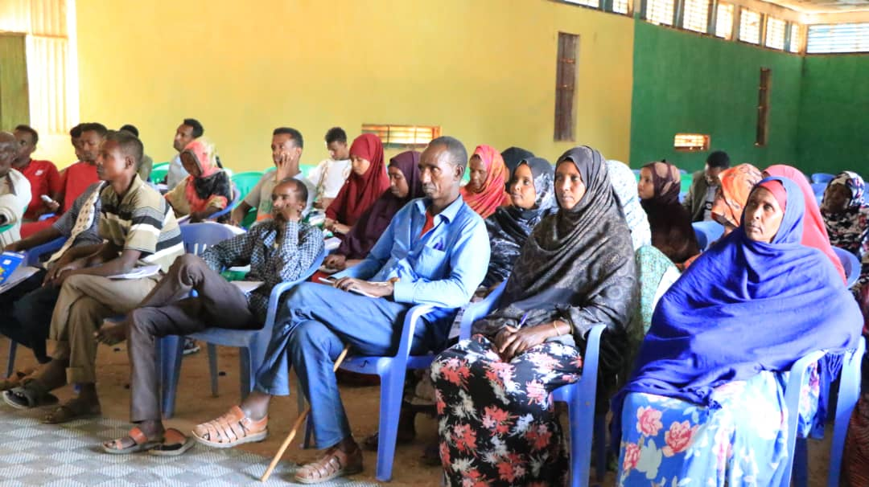

BLT Participatns in east imay of shabele zone in 2012

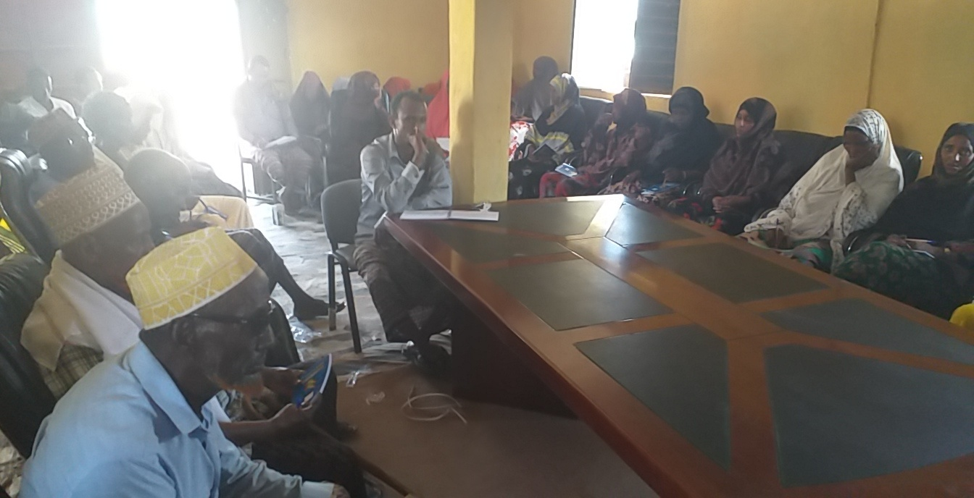

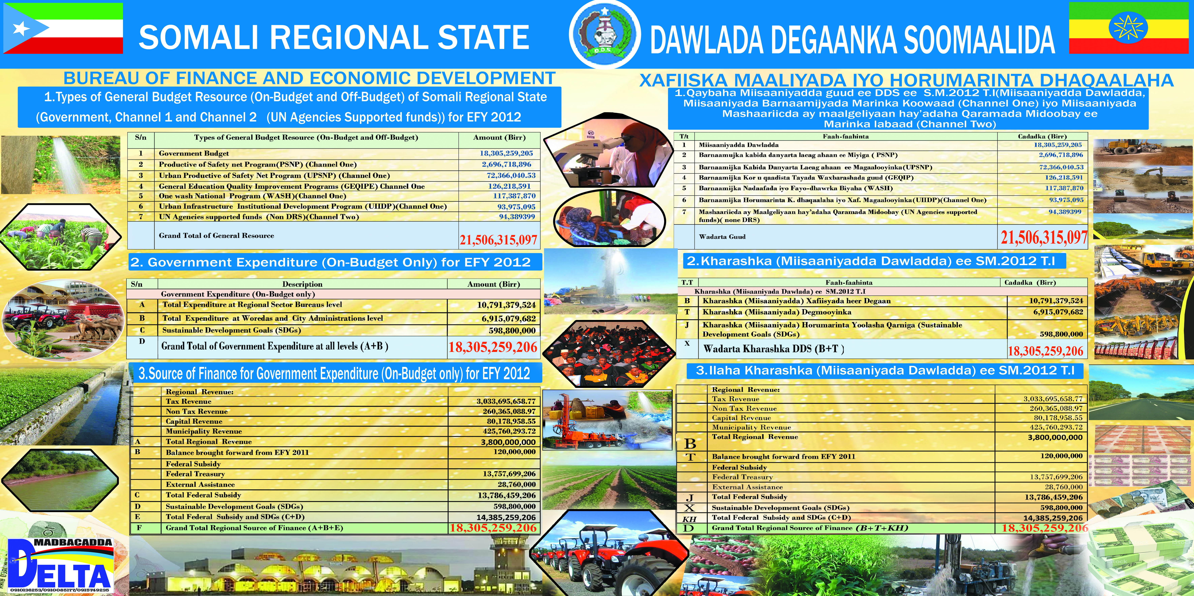
Budget dissemination of SRS Agriculture and Natural Resources Bureau for the year 2012 EFY

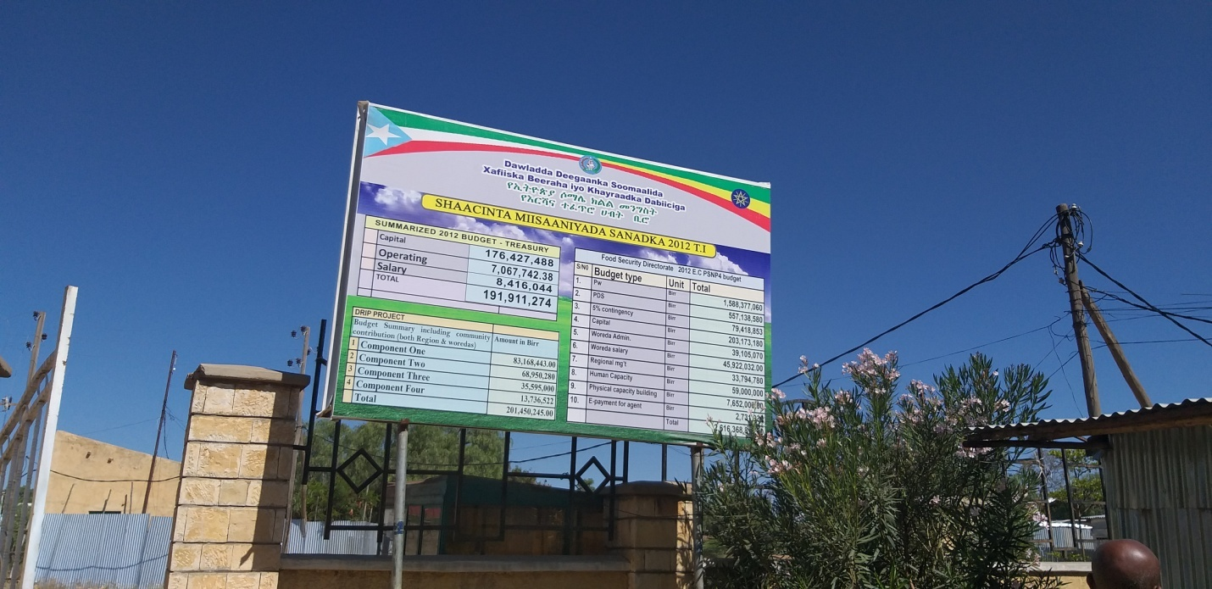
Budget dissemination of SRS Health Bureau for the year 2012 EFY

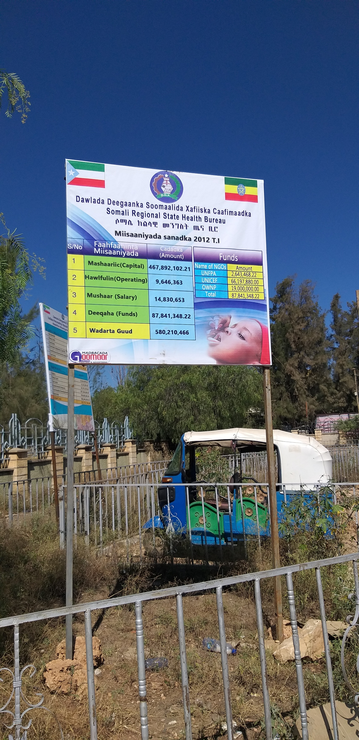

Budget dissemination for Regional Education Bureau in 2012 EFY

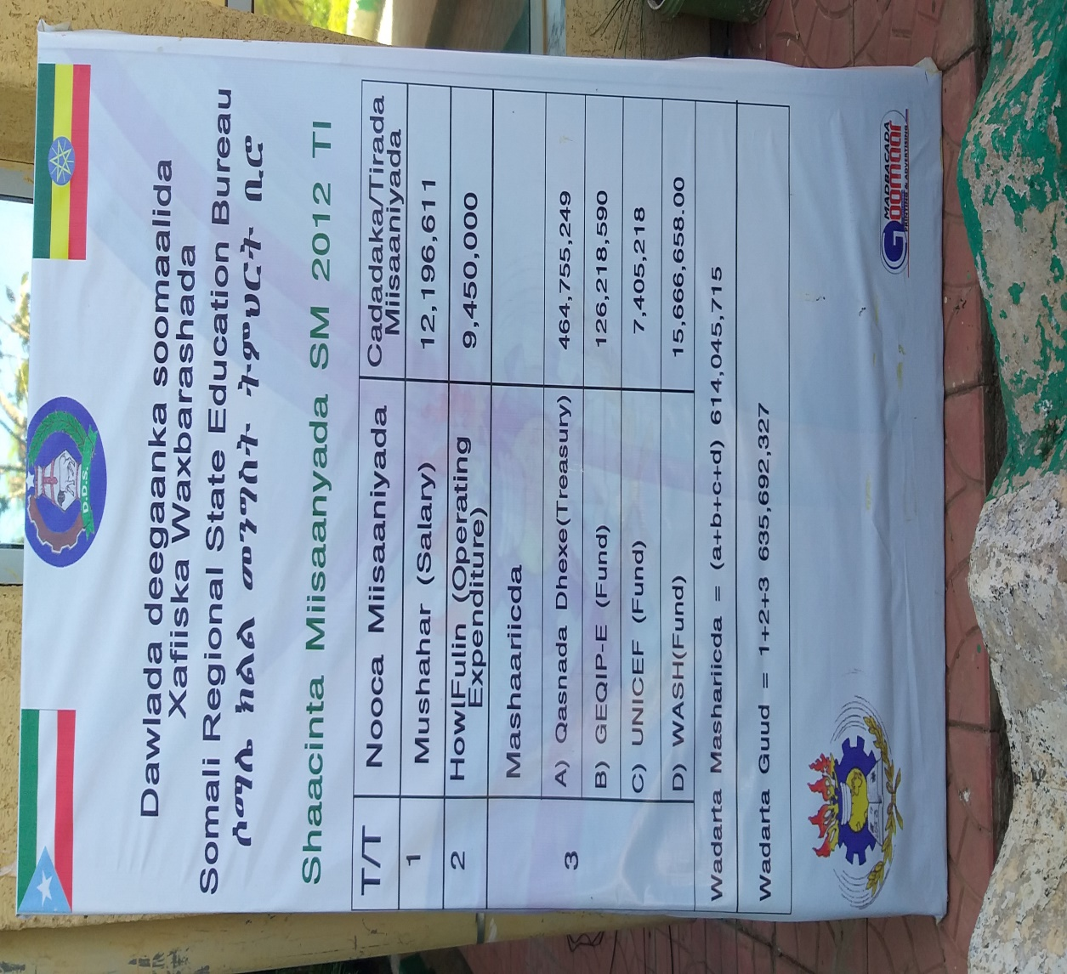

Budget dissemination for region’s irrigation bureau during 2012 EFY

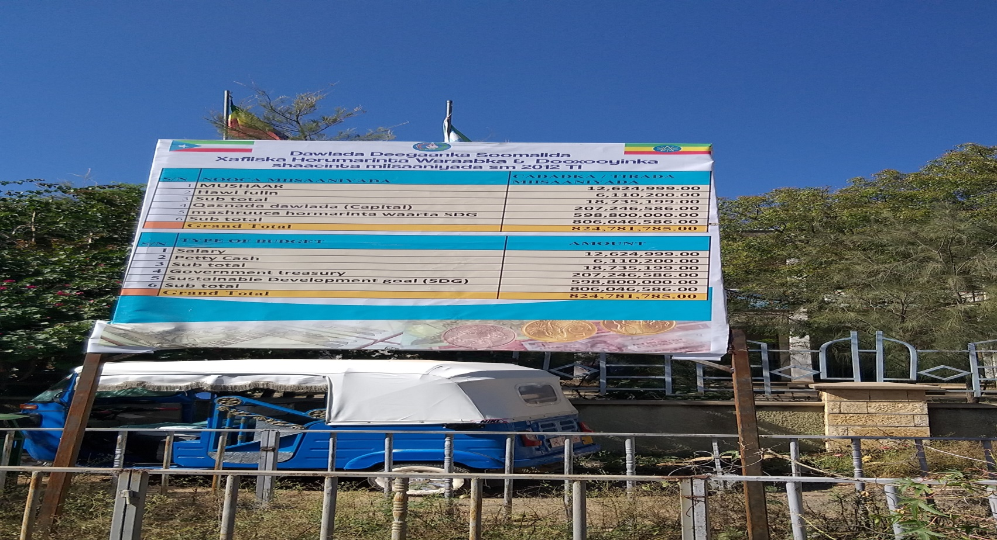

These are regional council participants on FTA workshop creation awareness during 2012 EFY.

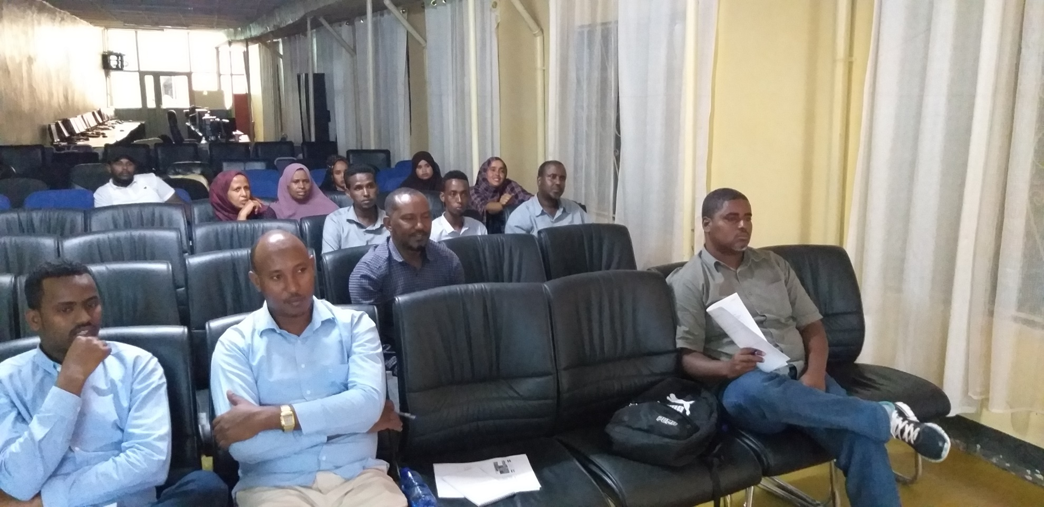

These are woreda council participants on FTA workshop creation awareness during 2012 EFY.

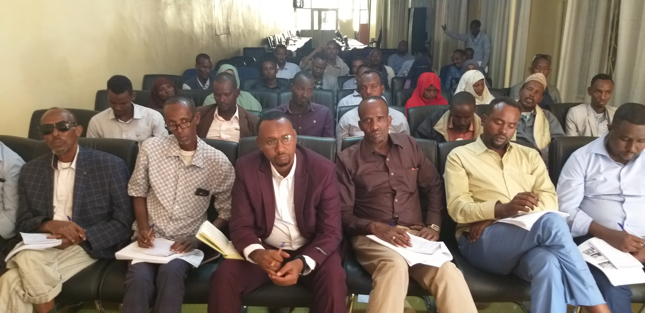

This picture shows budget dissemination for Ararso Woreda of jarar zone during 2012. It was photographed during Monitoring and evaluation travel.

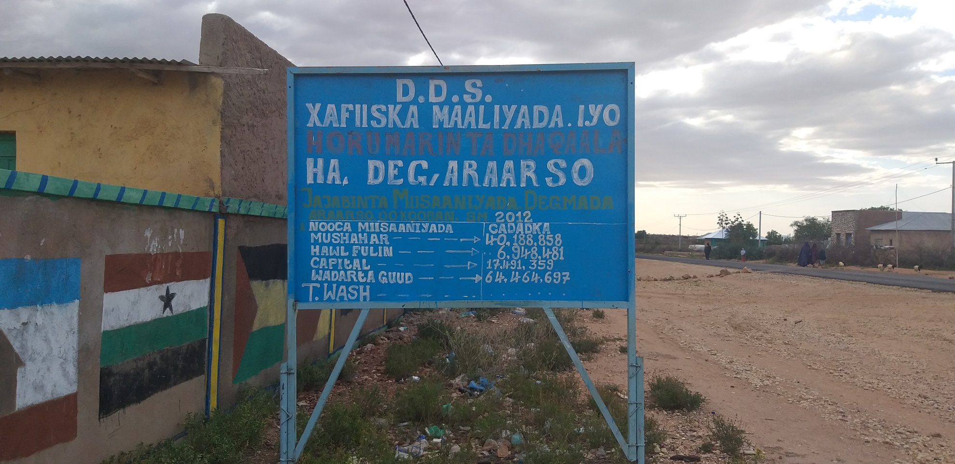

These are established local community committee for development agenda taking short brief on FTA

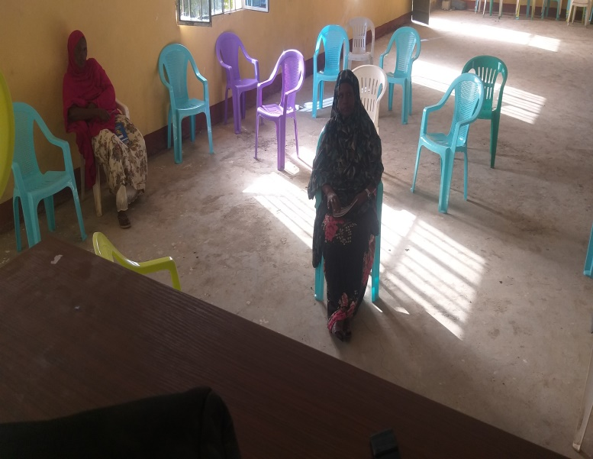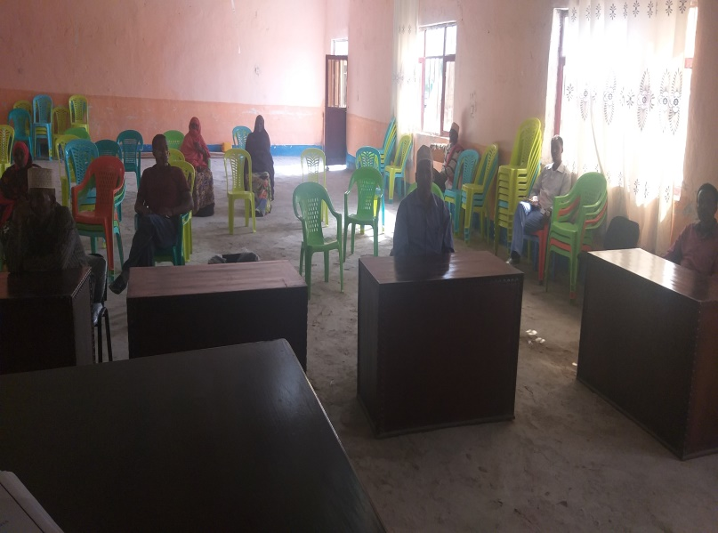

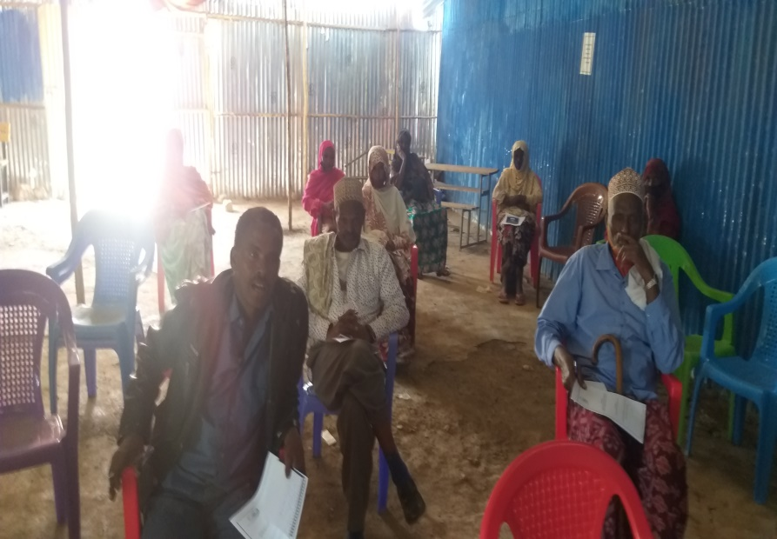

Shabeley woreda Annual budget for the year 2012 EFY

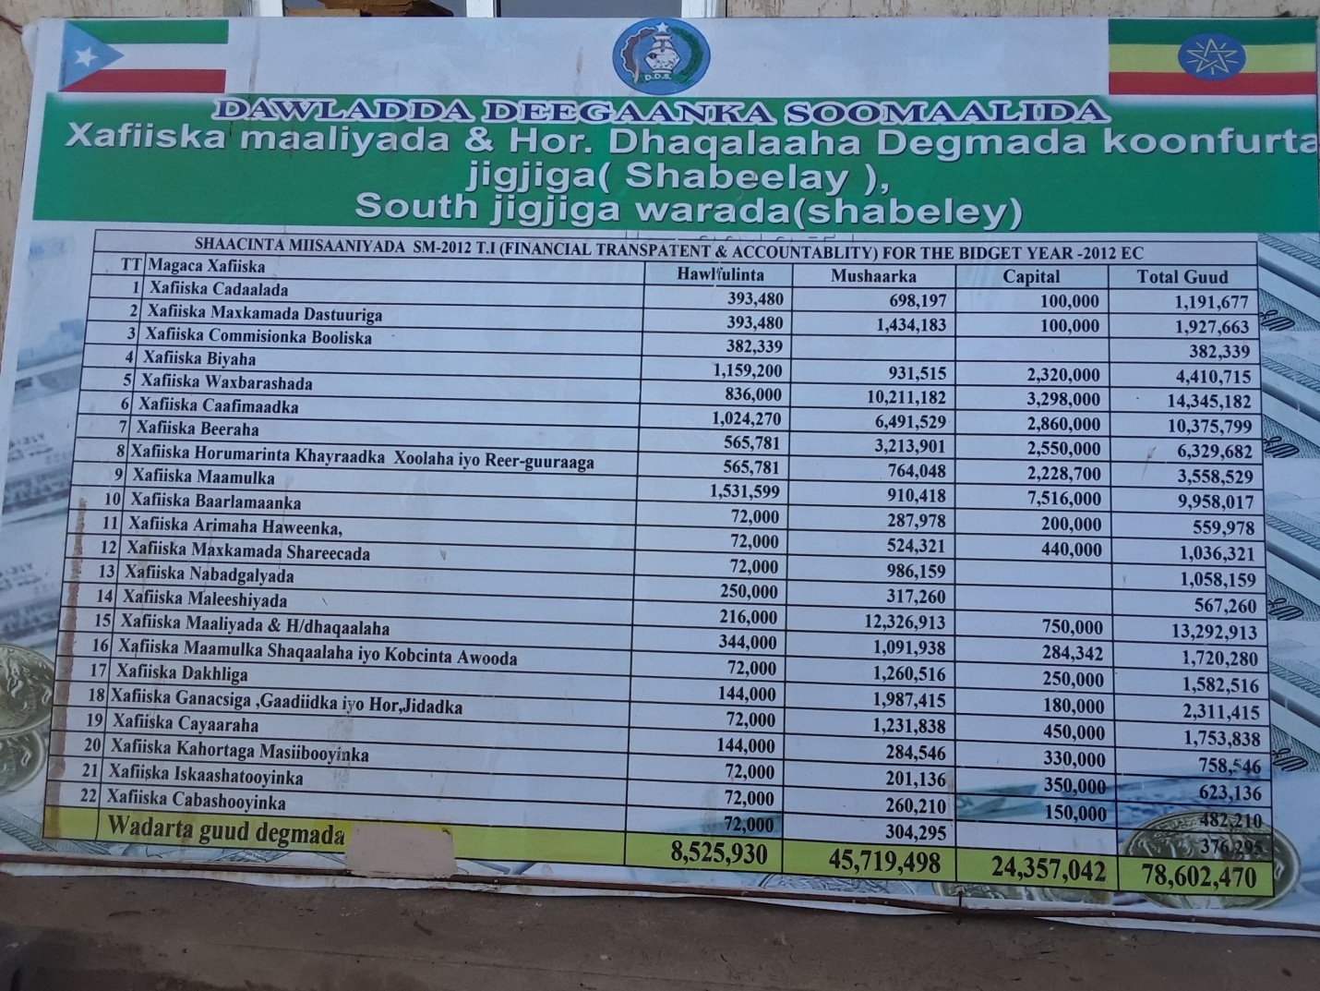

Below picture depicts some of FTA information templates filled and posted in Ayun woreda of nogob zone

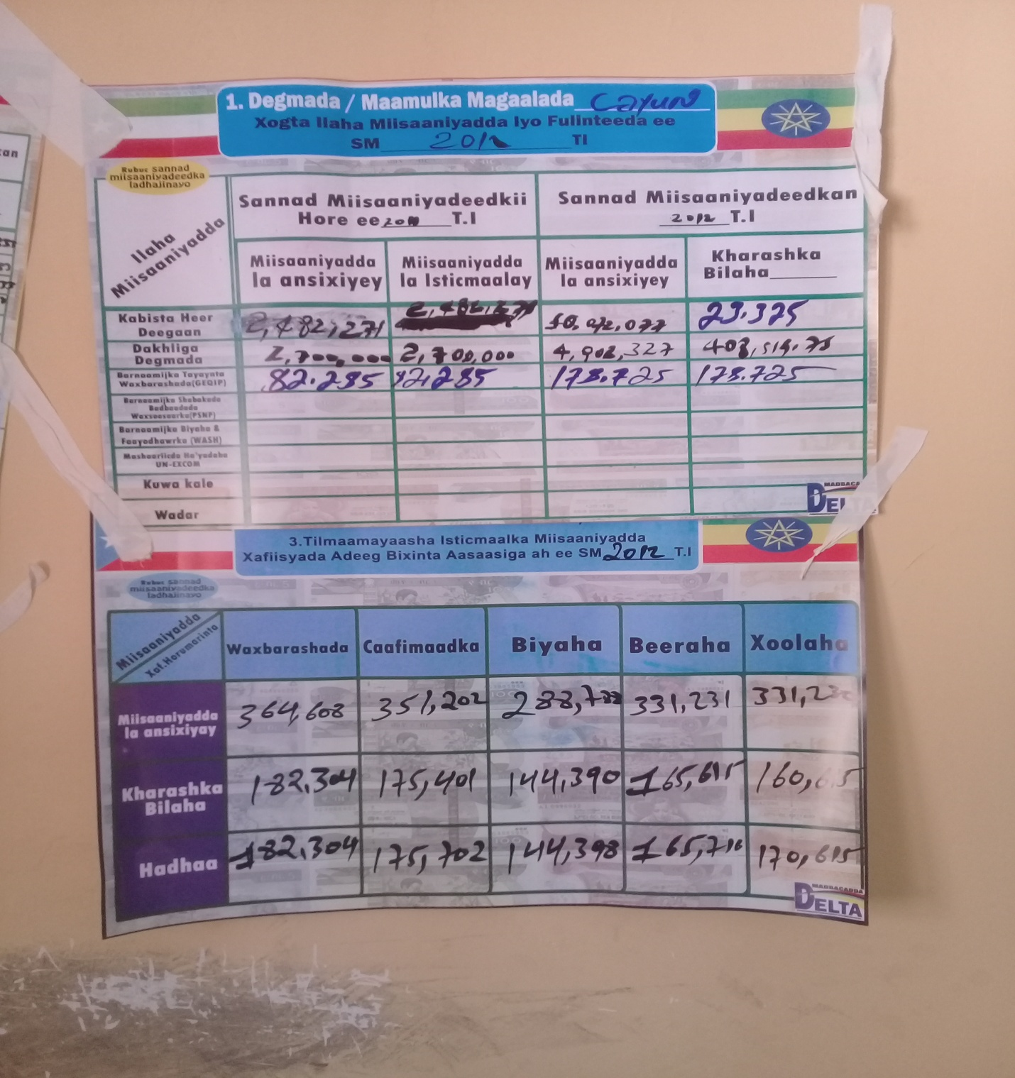

A-1 - Format for assessing the coverage of FTA information dissemination

Budget and Expenditure Information Dissemination at Woreda Level:
From Maskaram 2011 to SANE 2012 E.C
Region/City Adm. | No. of Zones | No. of Woredas\ City Adm. | Medias that used to post budget and expenditure information |  |  |  |  |  |  |  |  |  |  |  | Remark
 |  |  | Templates |  |  |  | Mass medias
 |  |  | Quarterly | Semi Annually | Annual | Coverage in % | TV | Radio | Others | Brushers | Thank You Cards | Printing on Dressings | Printing on banner | Printing on  Magazine/Journal
Somali regional state | 11 | 99 | 99 | 87 | - | 94 | √ | √ | - √ | √ |  |  | √ | √

- A weekly TV and Radio Program on FTA of 30 minute air time was Purchased and broadcasted via Somali Region TV and FM Radio.

B.1 - Service Delivery Information at Regional Level:

List of Woredas that use revised service delivery templates at Woreda/Town level

Name of Regions / City Administrations | No. of Zone | No. of Woreda/ City Admin | Type of Service Facility |  |  |  | Remarks
 |  |  | Education | Health | Water | Agricultural Development
Somali regional state | 11 | 99 | √ | √ | √ | √ | We use the new revised service delivery templates at Woreda and at facility level.

C.1 - Service Delivery Information at Service Delivery Unit:

Number of Service Delivery Units that Disclose Service delivery Information for the public
In somali Regional State.

Name of Region/City Administration | No. of Zones | No. of Woreda/ City Admin. | Type of Service Facility
 |  |  | School |  | Health center (HC/Health Posts) |  | Water |  | Agriculture
 |  |  | Total No. of schools in the Woreda | No.of schools that posted the templates | Total No. of HC in the Woreda | No. of HC that posted the templates | Total No. of water points in the woreda | No. of water points that posted the templates | Total No. of FTC | No. of FTC that posted the templates
Somali | 11 | 99 | 2,985 | 1,459 | 207 | 129 | 4,459 | 457 | 267 | 156

WOREDA | 100%
Facility level | 75%

Type of Service Facility | Total No of Service Facility | Total No of Service Facility that posted template | %
School | 2,985 | 1,459 | 48%
Health center | 207 | 129 | 62%
Water points | 4,459 | 750 | 19%
Veterinary Health Posts | 2,759 | 490 | 18.1%
FTC | 267 | 152 | 56%
Budget literacy Training
 | Name of Region/City Administration | Category of the Society
 |  |  |  | Male | Female |  | Total | Females’ Participation in %
 | Somali Region State | Community leaders |  | 150 | 167 |  | 317 | Average 51.5%
 |  | Staff members |  | 193 | 184 |  | 377
 |  | Religious elders |  | 123 | 0 |  | 123
 |  | Elders |  | 157 | 0 |  | 157
 |  | Women |  | 0 | 269 |  | 269
 |  | Youth |  | 204 | 232 |  | 436
 |  | CSO, CBO |  | 41 | 65 |  | 106
 |  | Others |  | 103 | 112 |  | 215
 |  | Total |  | 971 | 1029 |  | 2000

- Summary of feedback from citizens on budget allocation and service delivery as a result of the Budget Literacy Training and FTA work and areas of expected impact or outcome

Areas of impact or outcome |  | Best practices | Specific Woreda/Kebele example
1 | Empowering local voices (helped consultation on local planning, etc) | Increased citizen’s participation on budget and planning processes in all worda’s citizens. | Awbare
2 | Lowering corruption and misuse of public money | Corruption and misuse of public money has been minimized due to the financial transparency and improved citizen follow up and control. | Hudhat woreda of dawa zone
3 | Increased state of institutional responsiveness to citizens needs | Service delivery responsiveness to citizens needs has improved because of increase in the citizens involvement as we as working together with service providers. | In Kebribayah woreda, the citizens make complain about the budget allocation if it is not based on as per the approval
4 | Building new spaces for citizens’ engagement. | Citizens have been engaged to follow up of the different basic services progress, as well as increased their contribution as ownership in terms labor, finance, providing teachers temporarily living house etc. | In Mula woreda of Fafan zone
5 | Leading to better budget oversight and utilization | It has led to better budget oversight in the utilization. For instance the citizens well understood about budget allocated for capital and for recurrent and how it has been utilized. | Citizens living in project site areas at woredas came and acquire budget information
6 | Improving accountability of local government in basic service delivery | As a result of preventing risk or mistakes, basic service providers frequently consult citizens which have slightly improved accountability of local government in basic service. | Most of woredas
7 | Sens of ownership has been created | As result of transparency and accountability, the community follow both allocation and utilization up since they believe it’s their resource | Tuli-guled of Fafan zone.

Progresses on FTA-SA Linkage
- Regarding to Social accoutnability (SA), except, Pre-budget discussion which wasn’t carried out this year, woreda social accountability committee participated all FTA-SA related issues. For instance, when local community committee for development agenda was established at woredas, the social community committee in woredas participated the workshop on FTA creation awareness, and among woredas Hirshin woreda of Fafan zones can be mensioned.
- Likewise, woreda SACs of the 21 districts which SA exist, were invited and participated during budget literacy training organized by Regional PFM team. So that, Both FTA-SA teams can be well aware on how public budget and planning process is all about.
- FTA-SA radio Program has been organized and broadcasted through FM radio and Somali Television with 30 minute air time particularly on Sundays and Saterdays at 10:30 pm local time.

NB: Apart from the above listed points, there has not been any new activity achieved due to pandemic challenges.

