SOMALI REGION

Bureau of Finance

FTA Performances report for last two quarters 2015 EFY

By: Mohammed Omer
FTA, Focal person

Dir, 2015 EFY
Introduction.
The purpose of this report is to present about FTA Performances during last six months as Major financial Transparency and accountability (FTA) activities executed during first and second quarters of 2015 EFY.
Background.
In an effort to reduce poverty and enhance decentralized public service delivery to the poor, the Government of Ethiopia (GoE) and international development partners have embarked on a new mechanism known as Investment Project Fund (IPF) aimed to Promote Poverty reduction and sustainable development of member countries by providing financial and related operational support to specific project that promote broad-based economic growth, contribute to social and environmental sustainability, enhance the effectiveness of public and private sectors, or otherwise contribute to overall development of member states.
Investment project financing is comprised of Bank loans and bank guarantees. IPF supports projects with defined development objectives, activities and results. Transparency and Accountability is one of the key pillars of the governments' Promotion of Basic Services (PBS) national program. The program includes support for enhancing transparency and accountability by deepening engagement and strengthening “the voice” of citizens and citizen representative groups on public planning, budget processes and public service delivery.
Planned activities:
(Ba1) Increased Financial Transparency and Accountability (FTA)
The following activity has been a planned in the last one quarter for this year 2015EFY.
- Post large banners on regions annually approved budget.
- Printing large bill boards printed on this year’s approved budget in jigjiga city
- Prepare and print budget expenditures, basic service delivery standards by using Templates.
- Increase citizens awareness and information on public budgeting through different platforms (Mass media, school mini media, local community organizations, and other local based innovative thoughts)
- Printing, disseminating and posting of audit and procurement templates.
- Prepare, produce and disseminate citizens budget at regional level.
Achieved Activities:
During the last six months, the following activity has been achieved under FTA components:
During last two months i.e. Diqimt and hidhar, the following activity has been achieved under FTA components:
- Large bill boards depicting the budget of the region have been posted in eight popular areas in the jigjga city.
- 23 persons containing both FTA Cubs committee and local community committee for development agenda was established at 5 woredas namely Shabelay, Goljano, Fiq, Hamaro and Yahob.
- 1,782 pieces of FT templates for budget information and service delivery has been produced and distributed to woredas, posted.
- Budget literacy training was successfully conducted in 22 woredas of shabele and afdher zones in which 1100 participants benefited this training. The participants contained 604 males and 496 females respectively.
- A documentary film narrating the performance of regional sector budget as part of financial transparency and accountability was produced and is about to broadcast via government or private meida.
- 495 pieces of woreda citizens budget has been in preparation and most probably will be finished on just after five days.
- 270 pieces of Regional citizen budget has been prepared and is about accomplish for distribution.

Service Delivery Information at Regional Level:

List of Woredas that use revised service delivery templates at Woreda/Town level

Name of Regions / City Administrations | No. of Zone | No. of Woreda/ City Admin | Type of Service Facility |  |  |  | Remarks
 |  |  | Education | Health | Water | Agricultural Development
Ethiopian Somali | 11 | 99 | √ | √ | √ | √ | We use the new revised service delivery templates at Woreda and at facility level.

Name of Region/City Administration | Category of the Society | 2015 EC
 |  | Male | Female | Total | Females’ Participation in %
Somali Region State | Woreda leaders | 73 | 52 | 125
 | Staff members | 96 | 53 | 149
 | Religious elders | 120 | 0 | 120
 | Elders | 118 | 0 | 118
 | Women | 0 | 165 | 165
 | Youth | 82 | 85 | 167
 | CSO, CBO | 85 | 84 | 169
 | Others | 30 | 57 | 87
 | Total | 604 | 496 | 1100

This picture shows BLT participants taking at lasdhankayre of qorahe zone
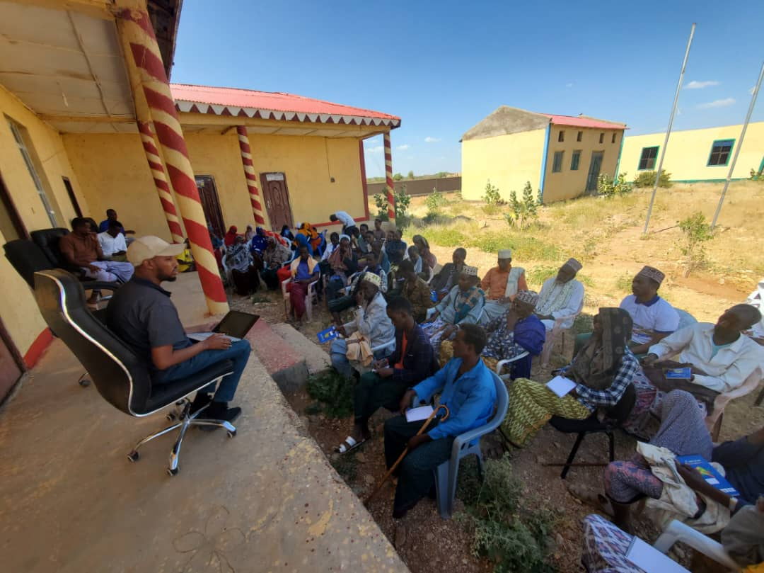

BLT Participants at Adadle woreda in 2015 EFY.

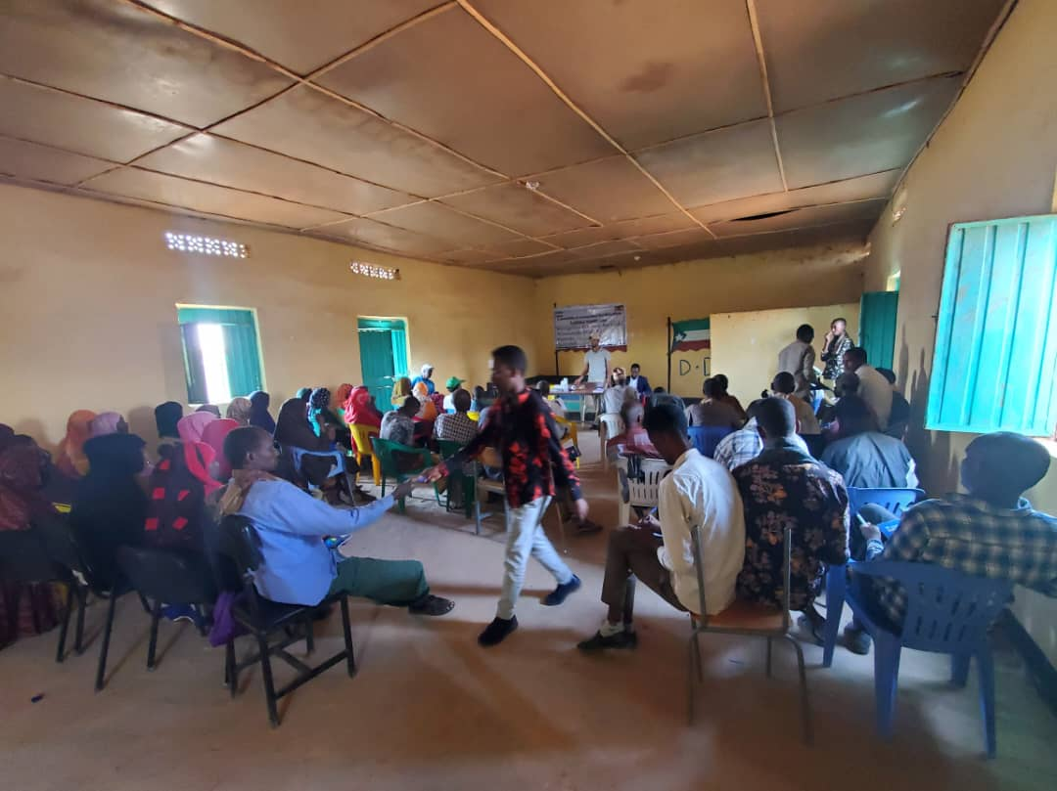

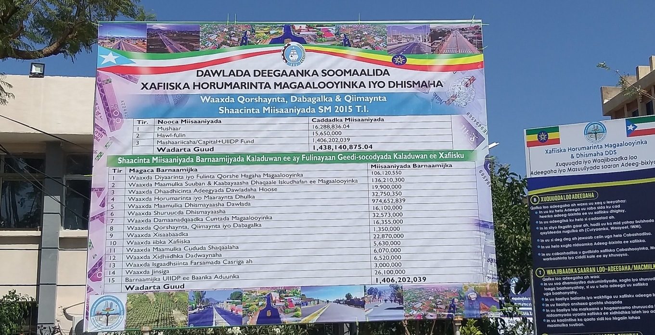

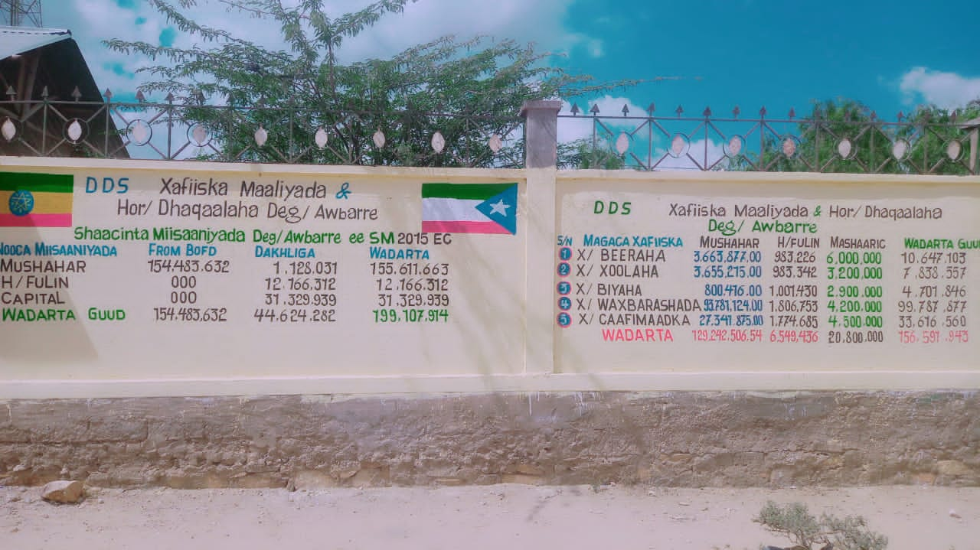
This picture depicts first quarter utilized budget and posted in front of the office at Qabribayah woreda
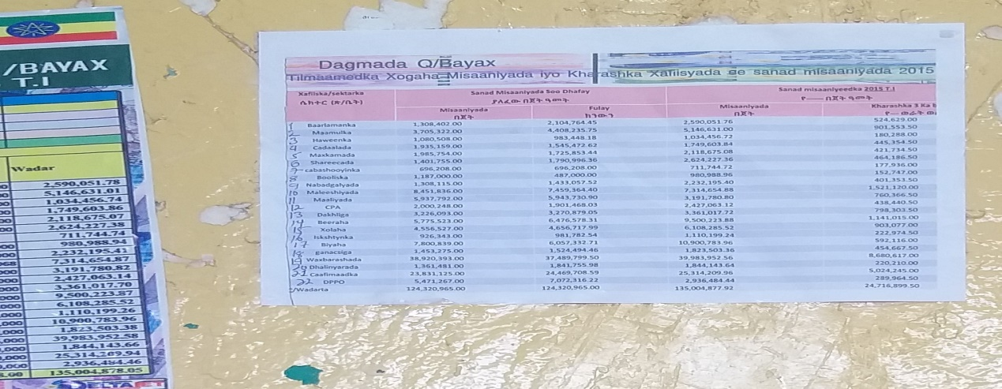

This is the budget of Regional water bureau posted in public in 2015 EFY.
